A REPORT

On

NEWS API WEBSITE

*Submitted*

*In partial fulfilment*

*For the award of the Degree of*

Bachelor of Technology in Department of Computer Science Engineering



**Submitted By:**

Harendra garg

Baibhav varshney

Prashant tomar

**Submitted To:**

Mr. Abhishek Kumar Tiwari

Department of Computer Science and Engineering

**GLA University Mathura Uttar Pradesh**

ACKNOWLEDGEMENT

It is my pleasure to be indebted to various people, who directly or indirectly contributed in the development of this work and who influenced our thinking, behavior and acts during the course of study. We express our sincere gratitude to **Mr. Sanjay Madaan,** for providing us an opportunity to undergo this Project as the part of the curriculum.

We are thankful to **Mr. Sanjay Madaan,** for his support, cooperation, and motivation provided to us during the training for constant inspiration, presence and blessings.

We would also like to thank our **H.O.D Mr. Rohit Agarwal** for her valuable suggestions which helps us lot in completion of this project.

We also extend our sincere appreciation to **Mr. Sanjay Madaan,** who provided his valuable suggestions and precious time in accomplishing our Project report.

Lastly, we would like to thank the almighty and our parents for their moral support and friends with whom we shared our day-to-day experience and received lots of suggestions that improved our quality of work.

**TABLE OF CONTENTS**

ABSTRACT 5

1. INTRODUCTION 6

PROJECT AIMS AND OBJECTIVES 6

BACKGROUND OF PROJECT 7

OPERATION ENVIRONMENT 8

1. SYSTEM ANALYSIS 9

SOFTWARE REQUIREMENT SPECIFICATION 9

EXISTING VS PROPOSED 15

SOFTWARE TOOL USED 16

1. SYSTEM IMPLEMENTATION 30

MODULE DESCRIPTION 30

SCREEN SHOTS 80

1. SYSTEM TESTING 85

UNIT TESTING 85

INTEGRATION TESTING 87

1. CONCLUSION & FUTURE SCOPE 88
2. REFERENCES 89

### Abstract

##### Online Library Management System is a system which maintains the information about the books present in the library, their authors, the members of library to whom books are issued, library staff and all. This is very difficult to organize manually. Maintenance of all this information manually is a very complex task.

Owing to the advancement of technology, organization of an Online Library becomes much simple. The Online Library Management has been designed to computerize and automate the operations performed over the information about the members, book issues and returns and all other operations. This computerization of library helps in many instances of its maintenances. It reduces the workload of management as most of the manual work done is reduced

**CHAPTER 1 INTRODUCTION**

This chapter gives an overview about the aim , objectives ,background and operation environment of the system.

#### PROJECT AIMS AND OBJECTIVES

Building a web project using a News API can serve various aims and objectives, depending on your intentions and the features you implement. Here are some common aims and objectives for such a project:

* Offer a Centralized Information Hub:
* Combat Misinformation:
* Accessibility and User Experience:
* Real-time Updates:

#### BACKGROUND OF PROJECT

The background of a News API-based project typically involves the context, motivations, and factors that lead to its inception. Here's a possible background for such a project:.

"In today's fast-paced world, staying updated with the latest news and developments across various domains is crucial. However, the vast amount of information dispersed across multiple sources often makes it challenging for individuals to efficiently access reliable news content. Recognizing this challenge, our project aims to address the need for a centralized platform that aggregates news from diverse and credible sources.

The project's inception stemmed from our team's passion for empowering individuals with accurate, diverse, and easily accessible information. We aim to contribute to a more informed society by providing a platform that not only delivers news efficiently but also fosters a community where users can engage, discuss, and share their insights on various topics.

|  |  |
| --- | --- |
| PROCESSOR | INTEL CORE PROCESSOR OR BETTER PERFORMANCE |
| OPERATIN GSYSTEM | WINDOWS VISTA ,WINDOWS7, UBUNTU |
| MEMORY | 1GB RAM OR MORE |
| HARD DISK SPACE | NA |
| DATABASE | NA |

## CHAPTER 2

**SYSTEM ANALYSIS**

In this chapter, we will discuss and analyze about the developing process of News Api webs Application including software requirement specification (SRS) and comparison between existing and proposed system . The functional and non functional requirements are included in SRS part to provide complete description and overview of system requirement before the developing process is carried out. Besides that, existing vs proposed provides a view of how the proposed system will be more efficient than the existing one

#### SOFTWARE REQUIREMENT SPECIFICATION

###### GENERAL DESCRIPTION

PRODUCT DESCRIPTION:

Introducing our groundbreaking news hub, designed to revolutionize how you stay informed! Our project is a cutting-edge online platform that simplifies your news consumption experience.

Say goodbye to the hassle of jumping between multiple websites or apps to catch up on the latest happenings. Our platform serves as your go-to destination, offering a diverse collection of news from reputable sources worldwide. It's like having your personalized newsstand right at your fingertips.

But it's not just about providing news; it's about trust and authenticity. We meticulously curate content from verified and credible sources, safeguarding you against misinformation. You can browse with confidence, knowing you're accessing reliable information.

Stay ahead with real-time updates! Our platform delivers news the moment it unfolds, keeping you in the loop with instant notifications for breaking stories. You won't miss a beat.

PROBLEM STATEMENT:

* Before computerized systems, several issues and challenges existed in various domains. Here are some problem statements that were prevalent:
* Manual Data Management: The reliance on manual methods for data storage, retrieval, and management led to inefficiencies, errors, and significant time consumption. Paper-based records were cumbersome to organize and prone to damage, loss, or misplacement.
* Limited Access to Information: Retrieving information was a tedious process due to physical archives or documents stored in different locations. This limited accessibility hindered timely decision-making and collaboration among individuals or departments.

#### SYSTEM OBJECTIVES

* + Efficient Information Aggregation: Create a system that seamlessly aggregates news content from diverse and reputable sources, offering users a comprehensive collection of articles, videos, and podcasts.
  + Personalized User Experience: Implement algorithms to analyze user preferences, browsing behavior, and interests to deliver customized news content tailored to each user's preferences
  + Real-time Updates and Notifications: Enable the system to provide real-time updates on breaking news and significant events, keeping users informed promptly.
  + These system objectives aim to guide the development and functionalities of the platform, prioritizing user-centric features, reliability, security, and adaptability to create a robust and engaging news aggregation system.

#### SYSTEM REQUIREMENTS

NON FUNCTIONAL REQUIREMENTS

* + Product Requirements EFFICIENCY REQUIREMENT

When news api web app will be implemented people will easily acess news as searching will be very faster .

RELIABILITY REQUIREMENT

The system should accurately performs fetching the accurate and trusted news

For the user

USABILITY REQUIREMENT

The system is designed for a user friendly environment so that user and people can perform the various tasks easily and in an effective way.

ORGANIZATIONAL REQUIREMENT IMPLEMENTATION REQUIREMNTS

In implementing whole system it uses html and css and javascript in front end with news api for fetching the latest news for the user

DELIVERY REQUIREMENTS

The whole system is expected to be delivered in One mnth of time with a weekly evaluation by the project guide.

FUNCTIONAL REQUIREMENTS

1. NORMAL USER

USER LOGIN

Description of

feature

This feature used by the user to login into system. They are required to enter user id and password before they are allowed to enter the system .The user id and password will be verified and if invalid id is there user is allowed to not enter the system.

Functional requirements

-user id is provided when they register

-The system must only allow user with valid id and password to enter the system

-The system performs authorization process which decides what user level can acess to.

-The user must be able to logout after they finished using system.

REGISTER NEW USER

Description of feature

This feature can be performed by all users to register new user to create account.

Functional requirements

-System must be able to verify information

-System must be able to delete information if information is wrong

REGISTER NEW BOOK

Description of feature

This feature allows to add new books to the library Functional requirements

-System must be able to verify information

-System must be able to enter number of copies into table.

- System must be able to not allow two books having same book id.

1.5 SEARCH BOOK

DESCRIPTION OF FEATURE

This feature is found in book maintenance part . we can search book based on book id , book name , publication or by author name.

Functional requirements

* System must be able to search the database based on select search type
* System must be able to filter book based on keyword enterd
* System must be able to show the filtered book in table view

Functional requirements

-System should be able to add detailed information about events .

-System should be able to display information on notice board available in the homepage of site

#### SOFTWARE AND HARDWARE REQUIREMENTS

This section describes the software and hardware requirements of the system SOFTWARE REQUIREMENTS

* + Operating system- Windows 7 is used as the operating system as it is stable and supports more features and is more user friendly
  + Development tools and Programming language- HTML is used to write the whole code and develop webpages with css, java script for whole web page

HARDWARE REQUIREMENTS

* + - nd

Intel core i5 2 generation is used as a processor because it is fast than other

processors an provide reliable and stable and we can run our pc for longtime. By using this processor we can keep on developing our project without any worries.

* + - * Ram 1 gb is used as it will provide fast reading and writing capabilities and will in turn support in processing.

###### Existing System:

* Manual Data Management: The reliance on manual methods for data storage, retrieval, and management led to inefficiencies, errors, and significant time consumption. Paper-based records were cumbersome to organize and prone to damage, loss, or misplacement
* Limited Access to Information: Retrieving information was a tedious process due to physical archives or documents stored in different locations. This limited accessibility hindered timely decision-making and collaboration among individuals or departments.

.

###### Proposed System:

To solve the inconveniences as mentioned in the existing system, an **News api web app** is proposed. The proposed system contains the following features:

After developing a news web app, there are several post-development tasks and considerations to ensure its success and effectiveness:

* + Search and Archive Functionality: Web apps allow users to search for specific topics or archived news articles quickly, enabling easier access to past information that might not be readily available in traditional media
  + **Cost-effective:** Users can access a vast array of news content without the need for individual subscriptions to multiple newspapers or magazines, potentially reducing overall costs.
  + Environmentally Friendly: News web apps reduce the consumption of physical resources like paper and ink, contributing to a more eco-friendly approach to news consumption compared to printed newspapers.
  + Real-time Updates: The app delivers real-time updates on breaking news or developing stories, ensuring users are promptly informed about the latest events as they happen.

#### SOFTWARE TOOLS USED

The whole Project is divided in two parts the front end and the API call. Front end

The front end is designed using of html ,css, Java script

HTML- **HTML**or**Hyper Text Markup Language**is the main markuplanguage for creating web pages and other information that can be displayed in a web browser.HTML is written in the form of HTML elements consisting of *tags* enclosed in angle brackets (like <html>), within the web page content. HTML tags most commonly come in pairs like <h1> and </h1>, although some tags represent *empty elements* and so are unpaired, for example <img>. The first tag in a pair is the *start tag*, and the second tag is the *end tag* (they are also called *opening tags* and *closing tags*). In between these tags web designers can add text, further tags, comments and other types of text-based content. The purpose of a web browser is to read HTML documents and compose them into visible or audible web pages. The browser does not display the HTML tags, but uses the tags to interpret the content of the page.HTML elements form the building blocks of all websites. HTML allows images and objects to be embedded and can be used to create interactive forms. It provides a means to create structured documents by denoting structural semantics for text such as headings, paragraphs, lists, links, quotes and other items. It can embed scripts written in languages such as JavaScript which affect the behavior of HTML web pages.

 CSS- **Cascading Style Sheets**(**CSS**) is a style sheet language used fordescribing the look and formatting of a document written in a markup language. While most often used to style web pages and interfaces written in HTML and XHTML, the language can be applied to any kind

of XML document, including plain XML, SVG and XUL. CSS is a cornerstone specification of the web and almost all web pages use CSS style sheets to describe their presentation.CSS is designed primarily to enable the separation of document content from document presentation, including elements such as the layout, colors, and fonts. This separation can improve content accessibility, provide more flexibility and control in the specification.

of presentation characteristics, enable multiple pages to share formatting, and reduce complexity and repetition in the structural content (such as by allowing for table less web design).CSS can also allow the same markup page to be presented in different styles for different rendering methods, such as on-screen, in print, by voice (when

read out by a speech-based browser or screen reader) and on Braille-based, tactile devices. It can also be used to allow the web page to display differently depending on the screen size or device on which it is being viewed. While the author of a document typically links that document to a CSS file, readers can use a different style sheet, perhaps one on their own computer, to override the one the author has specified. However if the author or the reader did not link the document to a specific style sheet the default style of the browser will be applied.CSS specifies a priority scheme to determine which style rules apply if more than one rule matches against a particular element. In this so-called *cascade*, priorities or *weights* are calculated and assigned to rules, so that the results are predictable.

JAVA SCRIPT- **JavaScript**(**JS**) is a dynamic computer programming language. It is most commonly used as part of web browsers, whose implementations allow client- side scripts to interact with the user, control the browser, communicate asynchronously, and alter the document content that is displayed. It is also being used in server-side programming, game development and the creation of desktop and mobile applications. JavaScript is a prototype-based scripting language with dynamic typing and has first-class functions. Its syntax was influenced by C. JavaScript copies many names and naming conventions from Java, but the two languages are otherwise unrelated and have very different semantics. The key design principles within JavaScript are taken from

the Self and Scheme programming languages. It is a multi- paradigm language, supporting object-oriented, imperative,

and functional programming styles. The application of JavaScript to use outside of web pages—for example, in PDF documents, site-specific browsers, and desktop widgets—is also significant. Newer and faster JavaScript VMs and platforms built upon them (notably Node.js) have also increased the popularity of JavaScript for server-side web applications. On the client side, JavaScript was traditionally implemented as an interpreted language but just-in-time compilation is now performed by recent (post-2012) browsers.

API-Certainly! An API (Application Programming Interface) in JavaScript refers to a set of rules, protocols, and tools that allow different software applications or systems to communicate with each other. In web development, JavaScript often interacts with APIs to access external services, data, or functionality provided by other applications or servers

. Here's an overview of how APIs are used in JavaScript:

Types of APIs:

1.Web APIs: These are APIs provided by web browsers to enable access to browser features and functionalities. Examples include the DOM (Document Object Model) API, Fetch API for making HTTP requests, Geolocation API, etc.

2.Third-party APIs: These are APIs provided by external services or platforms that developers can integrate into their applications. For instance, social media APIs like Twitter API, Google Maps API, weather APIs, etc.

Using APIs in JavaScript:

1.Fetching Data: One common use of APIs in JavaScript involves fetching data from external sources (like servers or databases) using methods like fetch() or XMLHttpRequest.

2.Sending Requests: JavaScript can use APIs to send various types of requests, such as GET, POST, PUT, DELETE, etc., to interact with backend servers or external services.

3.Handling Responses: Once data is received from an API request, JavaScript processes the response data, often in JSON format, and manipulates the DOM or performs other actions based on the retrieved information.

4.Authentication: APIs often require authentication (like API keys or OAuth tokens). JavaScript handles authentication mechanisms to ensure secure communication with the API endpoints.

API Documentation:

API providers typically offer documentation detailing how to use their APIs, including endpoint URLs, request formats, response structures, authentication methods, and usage examples. JavaScript developers refer to this documentation for proper integration.

Asynchronous Nature:

APIs in JavaScript often involve asynchronous operations, such as fetching data from an API endpoint. This is handled using promises, async/await, or callback functions to manage the flow of data and ensure smooth execution.



Cross-Origin Resource Sharing (CORS):

JavaScript APIs might be subject to security restrictions, such as the same-origin policy. CORS headers are used to manage these restrictions when accessing resources from different origins.

Overall, APIs in JavaScript empower developers to create dynamic and interactive web applications by leveraging external services and data, expanding the functionality and capabilities of their projects.

## CHAPTER 3 SYSTEM IMPLEMENTATION

**Screenshot**

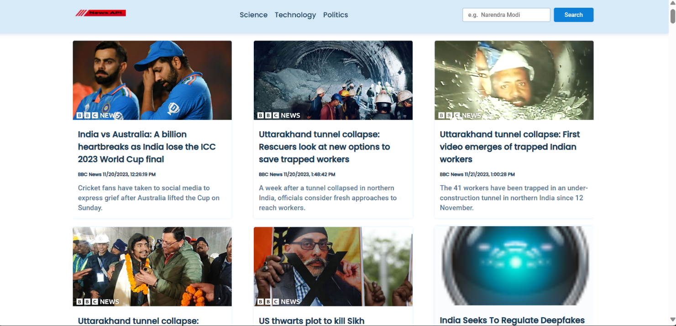

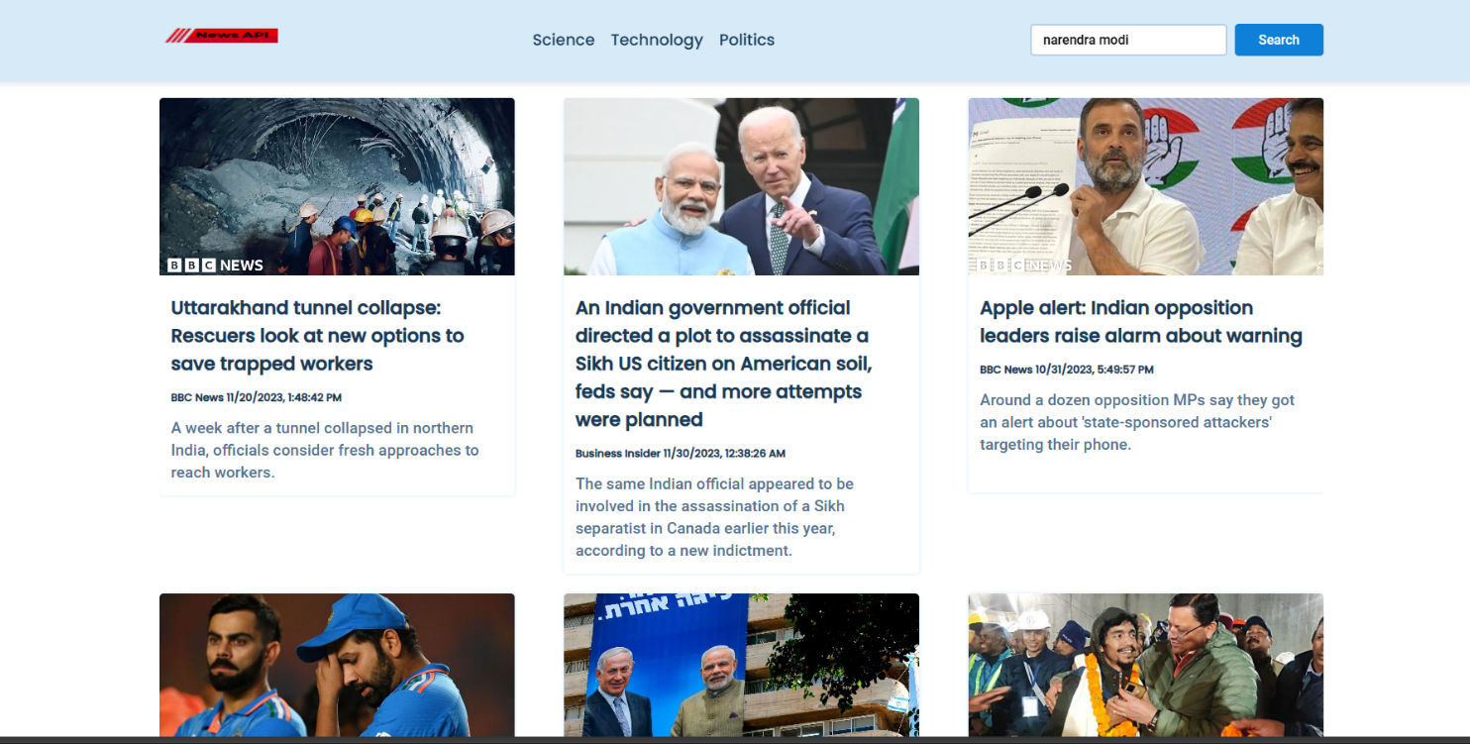

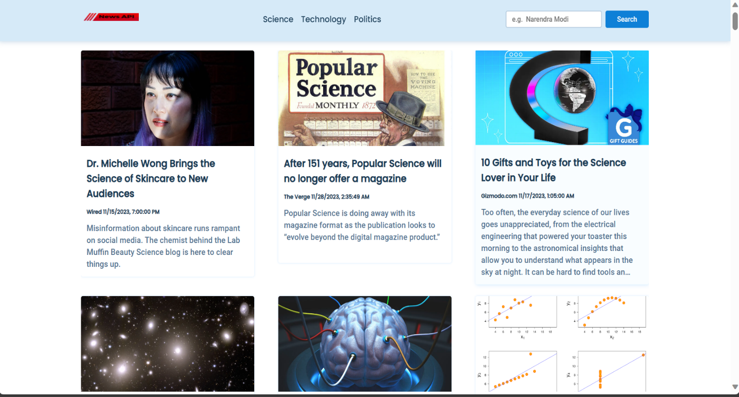

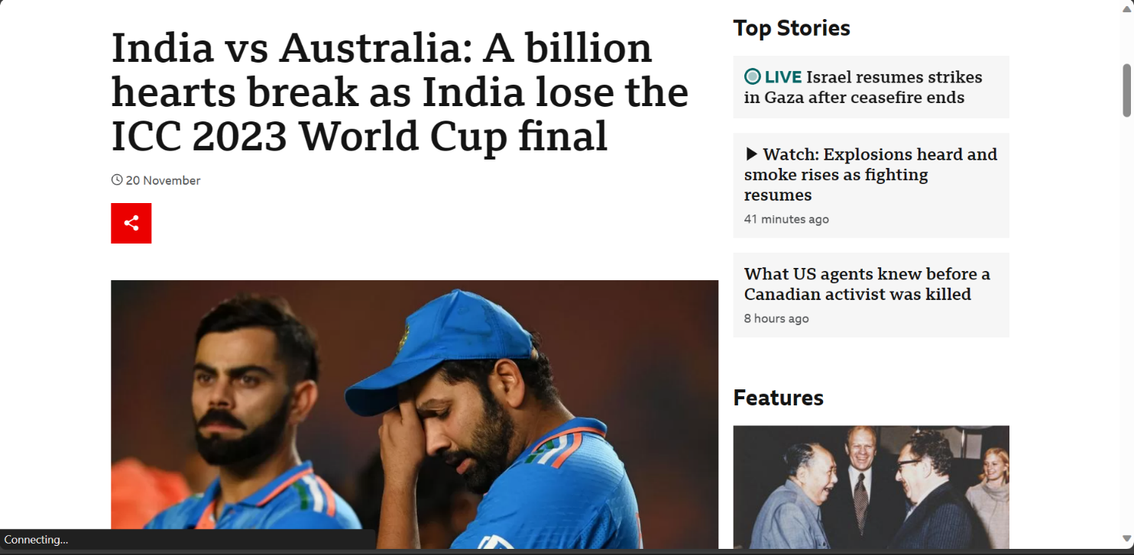

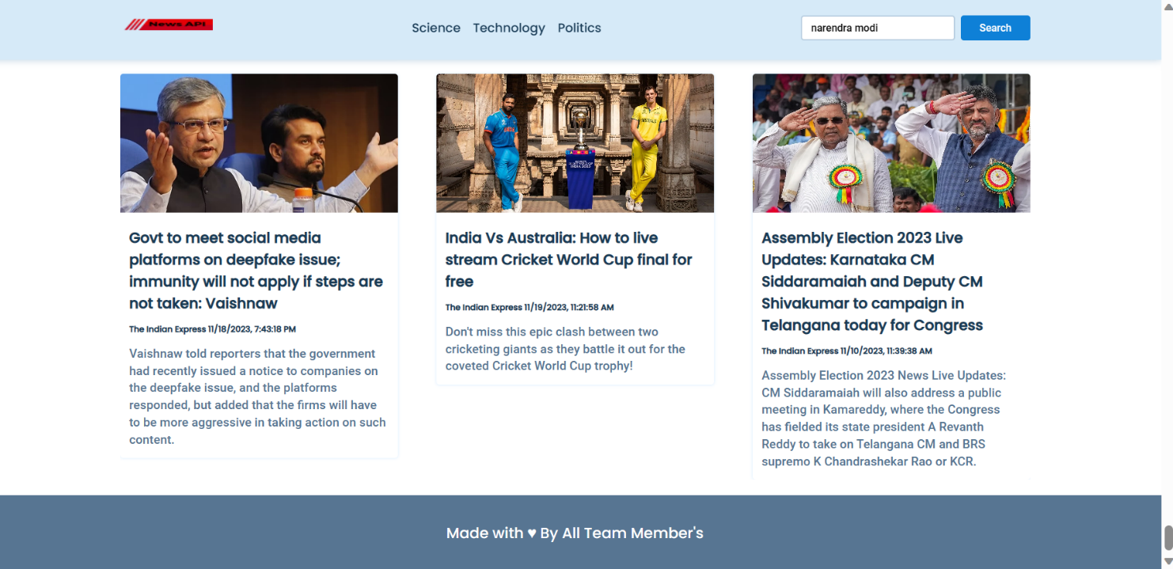

# CHAPTER 4 SYSTEM TESTING

The aim of the system testing process was to determine all defects in our project .The program was subjected to a set of test inputs and various observations were made and based on these observations it will be decided whether the program behaves as expected or not. Our Project went through two levels of testing

1. Unit testing
2. integration testing

## INTEGRATION TESTING

In this type of testing we test various integration of the project module by providing the input

.The primary objective is to test the module interfaces in order to ensure that no errors are occurring when one module invokes the other module.

## UNIT TESTING

Unit testing is undertaken when a module has been created and succesfully reviewed .In order to test a single module we need to provide a complete environment ie besides the module we would require

* + The procedures belonging to other modules that the module under test calls
  + A procedure to call the functions of the module under test with appropriate parameters

Identify Units for Testing:

Break down your project into smaller units or modules, such as functions responsible for API calls, data processing functions, authentication modules, etc.

Making Your Code Better:

Whenever you find problems during testing, you fix them, so your code becomes stronger and works better overall.

# CHAPTER 5 CONCLUSION & FUTURE SCOPE

The News API web project has successfully addressed the need for a centralized platform that aggregates news from various credible sources, offering users a personalized and convenient way to access up-to-date information. By leveraging modern technologies and robust testing methodologies, the project ensures reliable content delivery, user engagement, and a seamless user experience.

Future Scope:

Looking ahead, here are potential areas for further enhancement and expansion of the News API web project:

Multimedia Integration: Expand beyond articles to include multimedia content like videos, podcasts, or interactive infographics.

User-Generated Content: Implement features that allow users to contribute content or share their perspectives, fostering a more engaged and participatory community.

By focusing on these future avenues, the News API web project can evolve into a more comprehensive, engaging, and influential platform, staying ahead in the dynamic landscape of news consumption and user expectations

# CHAPTER 6 REFERENCES

<http://www.w3schools.com/html/html_intro.asp>

[http://www.Udemy.com/css/css_background.asp](http://www.udemy.com/css/css_background.asp) <http://www.w3schools.com/js/js_datatypes.asp>

